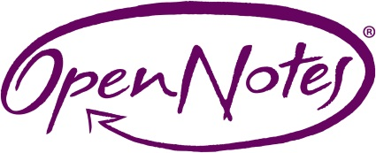 | OpenNotes by the Numbers

OpenNotes is a national movement dedicated to making health care more open and transparent by encouraging doctors, nurses, therapists, and others to share their visit notes with patients. Patients want OpenNotes. We’re learning that inviting patients to read notes may be an important way to improve communication, the safety and quality of care, and to enhance engagement and patient and provider satisfaction. OpenNotes is a valuable tool, especially among the most vulnerable, those with complex health conditions, and individuals who serve as care partners.

20,000 patients were in the original OpenNotes study.

20,000,000+ patients in the United States now have OpenNotes.

99% of patients in the original study said they want OpenNotes, and

85% of patients said OpenNotes helped them feel more in control of their care.
Annals of Internal Medicine, October 2012, Delbanco, Walker, et al

92% of VA patients say reading notes will help them remember the care plan better, and

90% of VA patients say notes help them take their medications as prescribed.
Veterans Affairs survey
29 Health experts provided recommendations for OpenNotes’ next step, OurNotes. Pilots inviting patients to co-produce notes will begin in 2018.
Annals of Internal Medicine, November 2017, Mafi, Walker, et al

99% of patients value access to notes. Top reasons include: remembering next steps, quicker access to results, gain confidence in clinicians, share with care partners.
JMIR, July 2017, Gerard et al

99% of patients feel the same or better about their physician after reading notes. Results were most striking among patients considered more vulnerable, indicating OpenNotes can improve trust, and

50% of clinicians felt that patient satisfaction and trust increased with note reading.
BMJ Quality & Safety, June 2016, Bell, Walker, et al

42% of patient who share notes with a care partner do so to manage healthcare activities, 30% share access in case of emergency and 18% share because they themselves do not use a computer
Journal of the American Medical Informatics Association, August 2016, Wolff, et al

88% of patients and 86% of care partners said they were able to prepare better questions for the doctor
Journal of the American Medical Informatics Association, August 2016, Wolff, et al

29% of patients who gave feedback about their notes discovered an error or inaccuracy in the record suggesting that patients can play an important role in the safety of their own care.

BMJ Quality & Safety, June 2016, Bell, Walker, et al

